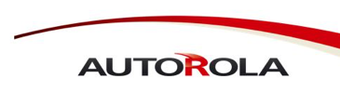
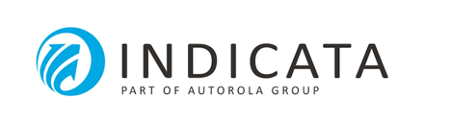
PRESS RELEASE

Autorola and Sofico forge partnership
to integrate INDICATA and Miles
Vehicle fleet managers across the world can now assess the risks and opportunities of their fleet more quickly

Brussels, 7 October 2019 – Autorola, a world leader in online remarketing and automotive IT solutions for professional fleet management, and Sofico, a global reference for software in the leasing and financial services industry, are going to work together to add a new dimension to the dynamic management of vehicle fleets. Thanks to this partnership, fleet and portfolio managers at leasing companies and other financial institutions that use Miles from Sofico will be able to maximise their fleets' portfolio value using real time market insights and specific KPIs. As a result they will be able to realise improved sales and more efficient risk management.

Erwin Coesens, Country Manager Autorola Belux, explains: “Traditionally, vehicle fleet managers have valued their assets on the basis of historical data. This often results in large differences in value that only come to light at the end of the vehicle contracts. INDICATA's real-time data allows vehicle managers to work proactively with their fleet and to constantly screen for business opportunities so that quick but well-considered decisions can be taken.” Jurgen Claus, International Business Development Manager at Autorola Group, adds: “Determining risk criteria on the basis of reliable, real-time data ensures improved efficiency and a much clearer view on current, ongoing and future challenges and opportunities.”

Sofico will integrate INDICATA's real-time data into its Miles solution. Miles has been specially developed to provide flexible and functional end-to-end solutions for the efficient management of vehicle fleets. The integration of this data will contribute to real-time insights at both the individual vehicle and portfolio levels.

Gémar Hompes, Managing Director at Sofico: “We have been in the fleet management business for over 30 years. Since the very beginning we have followed the market closely, and identified innovative trends and new technologies, to help our customers to manage their fleets even more effectively. One trend we have observed is that vehicle fleet managers and leasing companies are managing their vehicles with greater and more varying granularity: from years to minutes. Real time INDICATA data is a fantastic tool to give vehicle managers the insights they need to optimally manage their fleets, at any time.”

About INDICATA
INDICATA is part of the AUTOROLA GROUP. INDICATA is the next generation of business intelligence and market insights software for the management of used vehicle inventories. The platform, unlike any competitor in the market, brings a unique solution to improve profitability in used vehicle operations and protect residual values to the automotive industry and aligned sectors.
About AUTOROLA GROUP
AUTOROLA GROUP is a global leader in online remarketing and automotive IT solutions for professional used car and fleet management. AUTOROLA GROUP is headquartered in Denmark and the company has currently approximately 350 employees and subsidiaries in 19 countries across Europe, North America, Latin America and Asia Pacific.

About Sofico
Sofico is the world’s leading supplier of mission critical software solutions for automotive leasing, financing and fleet and mobility management companies. Its software is used by a broad range of renowned leasing companies all over the world.
Sofico was founded in 1988 in Ghent, Belgium and has over 30 years’ experience and business expertise in the leasing and fleet management industry. It is privately owned, independent and currently employs 280 people.
The company has installed its systems in 22 countries worldwide.

Press information:
Sandra Van Hauwaert, Square Egg Communications, sandra@square-egg.be, GSM 0497 251816.
Erwin Coesens, Autorola, erc@autorola.be, GSM 0475 959600.
Wim Bauwens, Sofico, wim.bauwens@sofico.be, +32 (0)9 210 80 40.

